PREDICTIVE MAINTANENCE OF ENGINES USING IBM CLOUD

1.INTRODUCTION
  - OVERVIEW

An engine or motor is a machine designed to convert one form of energy into mechanical energy. There are so many types of Engines . Engines are used by many different vehicles like Airoplane, Car, Bike. Sometimes due to some reason Engine may failure. Due to this failures you may face risk.So we Predict the failure of Engines.

  - Download the dataset.
  - Pre-process or clean the data.
  - Analyze the pre-process data.
  - Train the machine with pre-processed data .
  - using an appropriate machine learning algorithm .
  - Save the model and its dependencies .
  - Build a web application using flask that integrates with the model built.

b. PURPOSE

  - Engine failure is highly risky and needs a lot of time for repair. Unexpected failure leads to loss of money and time Predicting the failure prior, will save time, effort, money and sometimes even lives. The failure can be detected by installing the sensors and keeping a track of the values. The failure detection and predictive maintenance can be dealing with the engine failure for a threshold number of days.

  - The project aims to predict the failure of an engine by using machine learning to save loss of time and money thus improving productivity .
2.LITERATURE SURVEY

a.EXISTING PROBLEM
Predicting the failure of Engines using Machine learning There are so many methods to predict the failure of Engines like Random Forest Regression/Classification or DecisionTree Regression or K-Nearest Neighbors support Vector Machine but they are not much accurate.

b.PROPOSED SOLUTION
In this paper, we use Logistic Regression which is a Machine Learning Method.Logistic Regression is the most efficient and accurate method.This method predicts the failure of an engine most accurately.

3.THEORETICAL ANALYSIS

a. BLOCK DIAGRAM

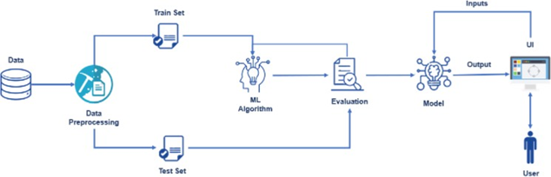

b.SOFTWARE DESIGN

To complete this project, you must require the following software concept and packages.
Anaconda navigator:
To download anaconda, go to www. anaconda.com
Anaconda is a free and open source distribution of the programming languages python and R. This distribution comes with the python interpreter and various packages related to machine learning and data science.

Python:
- Python is a popular programming language
- It is used for
- web development
- software development
- mathematics
- system scripting

Libraries used this model:

Open anaconda prompt as administrator
Type "pip install TensorFlow"
Type "pip install learns"
Type"pip install flask"
Type "pip install pandas"
Type "pip install Numb"

HTML AND CSS :
Html is used to create the actual content of the page, such as written text. Css handles the design or style of the website, including the layout, visual effects and background color.

4.EXPERIMENTAL INVESTIGATIONS

LOGISTIC REGRESSION :
Logistic Regression is a fundamental classification technique. It belongs to the group of linear classifiers and is somewhat similar to polynomial and linear regression. Logistic regression is fast and relatively uncomplicated, and it is convincing for you to interpret the results.

SKLearns:
Sci kit-learn is the most useful and robust library for machine learning in python. It provides a selection of efficient tools for machine learning and statistical modelling including classification,regression, and clustering.

Flask:
Flask is a popular web python web framework,meaning it is a third party Python library used for developing web applications.

5.FLOWCHART
- The user interacts with the user interface to give input
- Depending on the type of prediction (manual prediction ,sensor prediction). The output will produce.
- For manual Prediction user needs to give values.
- For sensor prediction, the system takes random values.
To accomplish this, we have to complete all the activities and tasks listed below
- Data collection
- Data pre-processing
- Model Building
Logistic regression
- Apllication Building
Create an HTML file
Build Python flask app
6.RESULTS
This project aim is to create a website which is used to predict the failure of engines with in 30 days.

Two types of predictions manual prediction and sensor prediction.

For this website, we use Logistic Regression which is the most accurate and efficient machine learning method.

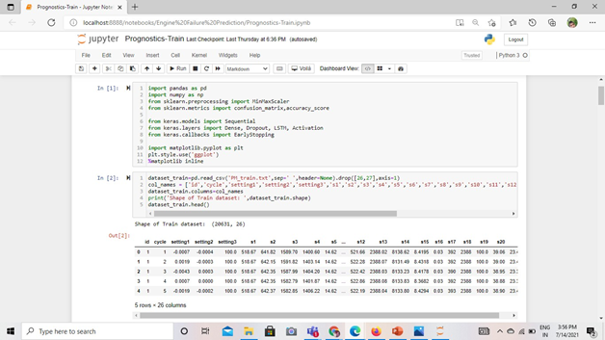
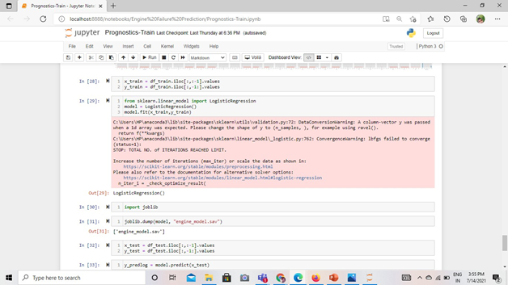
Python and machine learning libraries are used to develop
Logistic Regression
Learns
Pandas
numb
Flask

7.ADVANTAGES
- very high accuracy
- Both manual and sensor prediction
- Take less time to predict
- very efficient
- Save money and time
DISADVANTAGES
- Lots of data is required

8.APPLICATIONS

- predicting failure of engines

9.CONCLUSION

➤ In this work, we presented an efficient classification based predictive maintenance solution for the engines.
➤ In the website, we can predict the failure of Engines.it will save time and memory.
➤ Predicting the engine using both manual data and sensor data.
➤ Predictive modeling runs various iterations of the model to predict the effect of trenches in environment.

10.FUTURE SCOPE

- For future use of this website, we will add external data .
- We can use manual prediction for future predictions.

11.BIBILOGRAPHY

We use References of works on website.
https://en.m.wikipedia.org/wiki/predictive maintenance
https://towardsdatascience.com/

12.APPENDIX

a.SOURCE CODE
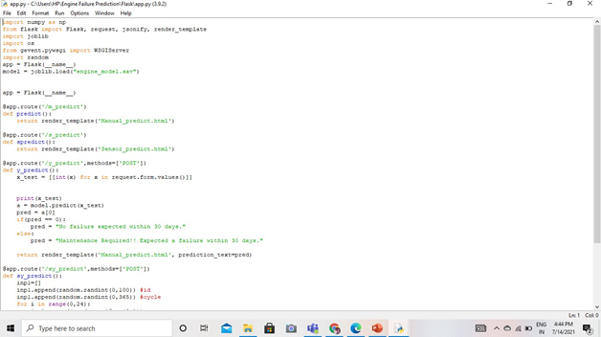
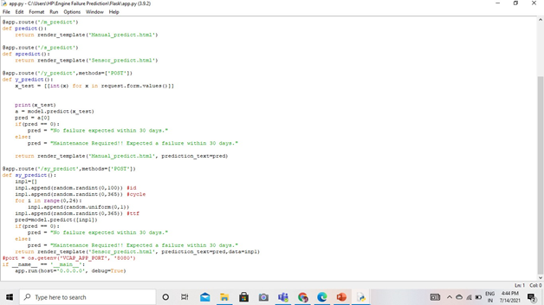

b.UI OUTPUT SCREENSHOT
